ECA5802-IOE AND AI DRIVEN SYSTEMS
EXPERIMENT 6(b): BENCHMARKING OF 5G/6G COMMUNICATION FOR IOE APPLICATIONS BASED ON THROUGHPUT,LATENCY,RELIABILITY AND ENERGY EFFICIENCY
OBJECTIVES:
- To simulate the People-Process-Data-Things (PPDT) framework for IoE applications.
- To evaluate data processing using the Edge, Fog, and Cloud computing pipeline.
- To analyze latency, efficiency, and performance of the IoE framework.

PROGRAM CODE:
import matplotlib.pyplot as plt
# Number of IoE devices
devices = [10, 50, 100, 200, 300, 400, 500]
# 5G network parameters (assumed)
capacity = 100 # Mbps
base_latency = 10 # ms
packet_success_rate = 0.98
energy_per_packet = 0.001 # Joules
# IoE device parameters
packet_size = 1200 # Bytes
packets_per_second = 20
simulation_time = 10 # Seconds
# Store results
throughput = []
latency = []
reliability = []
energy_efficiency = []
for n in devices:
# Total packets generated
total_packets = n * packets_per_second * simulation_time
# Offered traffic load (Mbps)
offered_load = (
n * packets_per_second * packet_size * 8 / 1e6
)
# Network utilization
utilization = offered_load / capacity
# 1. Throughput (Mbps)
t = min(
offered_load * packet_success_rate,
capacity
)
# 2. Latency (ms): increases with congestion
u = min(utilization, 0.95)
l = base_latency + 10 * u / (1 - u)
# 3. Reliability (%): decreases with congestion
r = 100 * packet_success_rate * max(
0, 1 - 0.2 * utilization
)
# 4. Energy efficiency (Mbit/J)
successful_packets = total_packets * r / 100
total_energy = (
total_packets
* energy_per_packet
* (1 + utilization)
)
e = (
successful_packets * packet_size * 8
/ total_energy / 1e6
)
# Store values
throughput.append(t)
latency.append(l)
reliability.append(r)
energy_efficiency.append(e)
# Display results
print(f"\nIoE Devices: {n}")
print(f"Offered Load : {offered_load:.2f} Mbps")
print(f"Throughput : {t:.2f} Mbps")
print(f"Latency : {l:.2f} ms")
print(f"Reliability : {r:.2f} %")
print(f"Energy Efficiency : {e:.2f} Mbit/J")
# Plot all four performance metrics
metrics = [
(throughput, "Throughput (Mbps)"),
(latency, "Latency (ms)"),
(reliability, "Reliability (%)"),
(energy_efficiency, "Energy Efficiency (Mbit/J)")
]
fig, axes = plt.subplots(2, 2, figsize=(11, 8))
for ax, (values, title) in zip(axes.flat, metrics):
ax.plot(devices, values, marker="o")
ax.set_title(title)
ax.set_xlabel("Number of IoE Devices")
ax.set_ylabel(title)
ax.grid(True)
plt.suptitle("5G Performance Benchmarking for IoE Applications")
plt.tight_layout()
plt.show()

OUTPUT GRAPH:
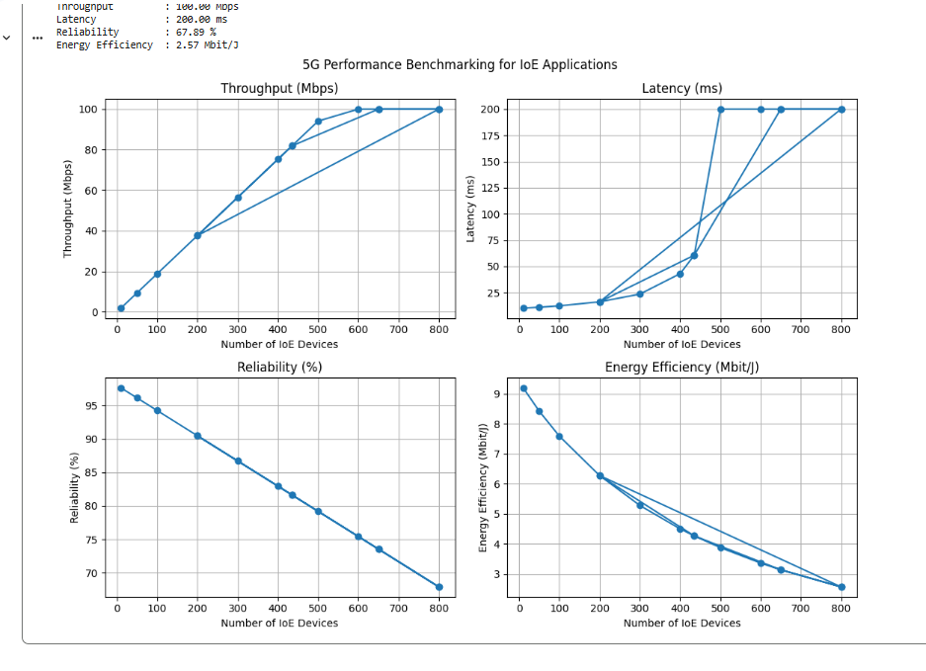

TABLE COLUMN:
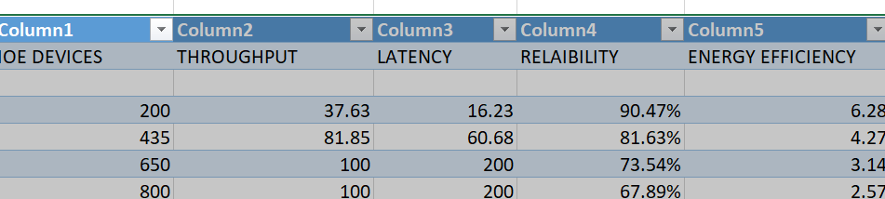

RESULT:
The People-Process-Data-Things (PPDT) IoE framework using the Edge-Fog-Cloud pipeline was simulated and studied. The performance of data processing, latency, and efficiency was evaluated. Thus, the framework supports efficient data management and decision-making in IoE applications.

